ALUMNI EMAIL (27th January 2025)
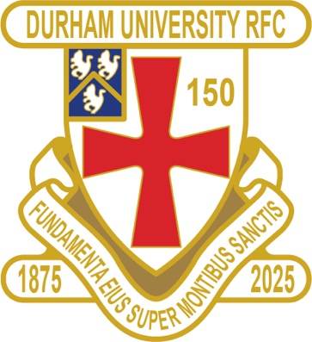
1875 CLUB
1875 CLUB DRAW JANUARY 2025
1st £ 100 15 JAMES METCALFE
2nd £ 50 52 MICHAEL HORROCKS TAYLOR
3rd £ 25 33 DAVID BARNES

Future draw & newsletter dates for 2025:
26 February + 19 March +16 April + 2/3 May

Thank you to all those alumni, supporters and parents for signing up to this vital fund-raising initiative.
We still URGENTLY need your support for DURFC – please see here for details on joining the DURFC Alumni 1875 Club for £10 per month, which includes free entry to the monthly draw. PLEASE JOIN NOW - Thank you in advance for your support
DURFC NEWS
Harry Willard has signed for a professional Japanese club for next year

RESULTS WEDNESDAY 22nd JANUARY 2025
1ST XV LEEDS BECKETT 1 WON 38-15 BSR
2nd XV NEWCASTLE 1 LOST 5-76 BUCS
3rd XV NO GAME
4th XV NEWCASTLE 4 WON 22-20 BUCS
5th XV NORTHUMBRIA 3 LOST 17-28 BUCS

FIXTURES SATURDAY 25th JANUARY 2025
PALATINATES XV ASHINGTON POSTPONED

FIXTURES WEDNESDAY 29th JANUARY 2025
1ST XV LOUGHBOROUGH AWAY KO 7pm BSR
2nd XV LOUGHBOROUGH 2 HOME KO 2pm BUCS
3rd XV NO GAME
4th XV LEEDS BECKETT 3 AWAY KO 2pm BUCS
5th XV NEWCASTLE 4 HOME KO 2pm BUCS

You can also see the results on our official DURFC website, whilst keeping you up to date with club news-www.durhamunirugby.com

Please follow the 1stXV live on twitter @durfc

TEAM PHOTOGRAPHS- HELP !!
Missing Team/ Club Photos from 1980-2011/12/13 / 2023/24 - Please forward your photos to keaysie@hotmail.co.uk so we can update our 150th Digital Photo / History book

ALUMNI NEWS THIS WEEK #BleedPalatinate

Max Pepper (2021-24) played on the wing for Newcastle Falcons away at Bristol Bears in the Premiership Ben Stevenson (2016-19) played on the other wing who scored two tries. Adam Brocklebank (2015-18) making it an incredible three starting Alumni in the Falcons starting team

In opposition Fitz Harding ( 2018-21) captained Bristol Bears

Paul Brown (2020-24) started for Exeter Chiefs against Saracens in the Premiership

👀 WATCH THIS SPACE 👀
DURFC CLUB & ALUMNI 150th CELEBRATIONS 2025

DURFC vs THE BARBARIANS
Saturday 3rd May 2025 KO 3pm

At Durham City Rugby Club Hollow Drift

TICKET LINK
https://fixr.co/event/durfc-v-the-barbarians-tickets-231750238

www.durfc1875.com

